

DEPARTMENT OF ARTIFICIAL INTELLIGENCE AND DATA SCIENCE
MINOR PROJECT REPORT
BANK CUSTOMER CHURN ANALYSIS AND PREDICTION
Prediction Problem Definition, Model Development, Evaluation and Comparison
Submitted by
JAISON X (814725243064)
JAYAPRAGASH B (814725243066)
NISHANTH M (814725243116)
II AI & DS – B
Under the Guidance of
V. EZHIL SWANLY
Submission Date: 24 October 2026

CERTIFICATE
This is to certify that the minor project report titled “Bank Customer Churn Analysis and Prediction” is submitted by JAISON X, JAYAPRAGASH B and NISHANTH M of the Department of Artificial Intelligence and Data Science, SRM TRP Engineering College, Tiruchirappalli. The report presents a machine-learning workflow covering problem definition, data preparation, model development, evaluation and comparison.

ACKNOWLEDGEMENT
We express our sincere gratitude to SRM TRP Engineering College and the Department of Artificial Intelligence and Data Science for providing us with the opportunity, infrastructure, and facilities to successfully complete this mini project.
We express our heartfelt gratitude to our Dr. Perumalraja, Professor & Head, Department of Artificial Intelligence and Data Science, for providing constant encouragement, valuable support, and a motivating academic environment that greatly contributed to the successful completion of this project.
We sincerely thank our project guide, Mr. V. Ezhil Swanly, Assistant Professor, Department of Artificial Intelligence and Data Science, for his valuable guidance, continuous encouragement, constructive suggestions, and unwavering support throughout the development of this project.
We also extend our sincere thanks to all the faculty members of the Department of Artificial Intelligence and Data Science for their valuable inputs and encouragement. We are grateful to our classmates and family members for their continuous support, cooperation, and motivation during the preparation of the customer churn dataset, data analysis notebook, and project report.
Finally, we acknowledge the bank customer dataset used for this study, as well as the open-source Python libraries and tools that supported the data preprocessing, analysis, visualization, and report preparation. Their availability greatly contributed to the successful completion of this mini project.
JAISON X
JAYAPRAGASH B
NISHANTH M

TABLE OF CONTENTS
- Abstract
- Chapter 1 – Problem Definition
- Chapter 2 – Data Preparation
- Chapter 3 – Model Development
- Chapter 4 – Model Evaluation
- Chapter 5 – Model Comparison
- Chapter 6 – Result Analysis
- Conclusion
- References
- Appendix – Code and Output

ABSTRACT
This project extends the mini project “Bank Customer Churn Analysis” into a supervised machine-learning workflow that classifies whether a SmartBank customer will churn (Exited = 1) or be retained (Exited = 0). The cleaned customer dataset (clean_df) from the mini project contains 10,000 records and 12 columns, with no missing values and no duplicate rows; 8,022 customers (80.22%) were retained and 1,978 (19.78%) churned. The earlier exploratory analysis found similar churn across geography, gender and age, and every pairwise correlation between the numeric features, including each feature with Exited, lay between −0.03 and 0.03.
Three classifiers are included: Logistic Regression, Decision Tree and Random Forest. Using a stratified 80/20 split (8,000 training and 2,000 test records), the notebook calculates accuracy, macro precision, macro recall, macro F1-score, classification reports, confusion matrices and feature importance. On this test split, Random Forest obtained the highest macro F1-score (0.4526), followed closely by Logistic Regression (0.4498) and Decision Tree (0.3636); however, all accuracy values lie between 0.37 and 0.51, which is close to chance level. Because the dataset was generated by simulation in the notebook, this outcome is expected, and the results are an educational demonstration only, not a basis for real banking decisions.
CHAPTER 1 – PROBLEM DEFINITION
1.1 Prediction Problem
The proposed task is supervised binary classification: use customer profile, account and engagement information to predict whether a customer churns.
1.2 Target Variable
Target variable: Exited. The value 0 represents a retained customer and 1 represents a churned customer, as defined in the mini project.
1.3 Feature Variables
Feature | Description | Role
CustomerID | Unique customer identifier | Identifier (not used)
CreditScore | Credit score of the customer | Input feature
Geography | Country (France, Spain, Germany) | Categorical input
Gender | Gender (Male, Female) | Categorical input
Age | Customer age in years | Input feature
Tenure | Years the customer has been with the bank | Input feature
Balance | Account balance of the customer | Input feature
NumOfProducts | Number of bank products held | Input feature
HasCrCard | Has a credit card (1 = Yes, 0 = No) | Binary input
IsActiveMember | Is an active member (1 = Yes, 0 = No) | Binary input
EstimatedSalary | Estimated salary of the customer | Input feature
Exited | Churn status (0 = Retained, 1 = Churned) | Target variable

1.4 Objectives
- Inspect the cleaned dataset (clean_df) from the mini project.
- Prepare the input features and target.
- Train three classification models.
- Evaluate and compare model performance.
- Discuss feature importance, limitations and future improvements.
CHAPTER 2 – DATA PREPARATION
2.1 Dataset Overview
Item | Known details from the mini project report
Raw dataset | 10,000 records, 12 columns
Cleaned dataset (clean_df) | 10,000 records, 12 columns
Raw missing values | 0 in every column
Duplicate rows | 0
Class distribution | Retained: 8,022 (80.22%); Churned: 1,978 (19.78%)
Columns | CustomerID, CreditScore, Geography, Gender, Age, Tenure, Balance, NumOfProducts, HasCrCard, IsActiveMember, EstimatedSalary, Exited

2.2 Preparation Procedure
- Save the cleaned dataset (clean_df) from the mini project notebook as a CSV file and upload it in Google Colab.
- Inspect dimensions, column names, missing values and duplicate rows.
- Check that the required columns are present.
- Encode Gender as 0/1 and Geography as one-hot columns; CustomerID is an identifier and is not used as a feature.
- Convert feature fields to numeric; separate X (12 input features) and y (Exited).
- Split the dataset into training and test sets using a stratified 80/20 split (8,000 training and 2,000 test records) so that the churn share is the same in both sets.
2.3 Data Preparation Output
The output printed by Colab for dataset shape, column names, missing values, duplicate rows, churn category counts and training/testing record counts is shown below.
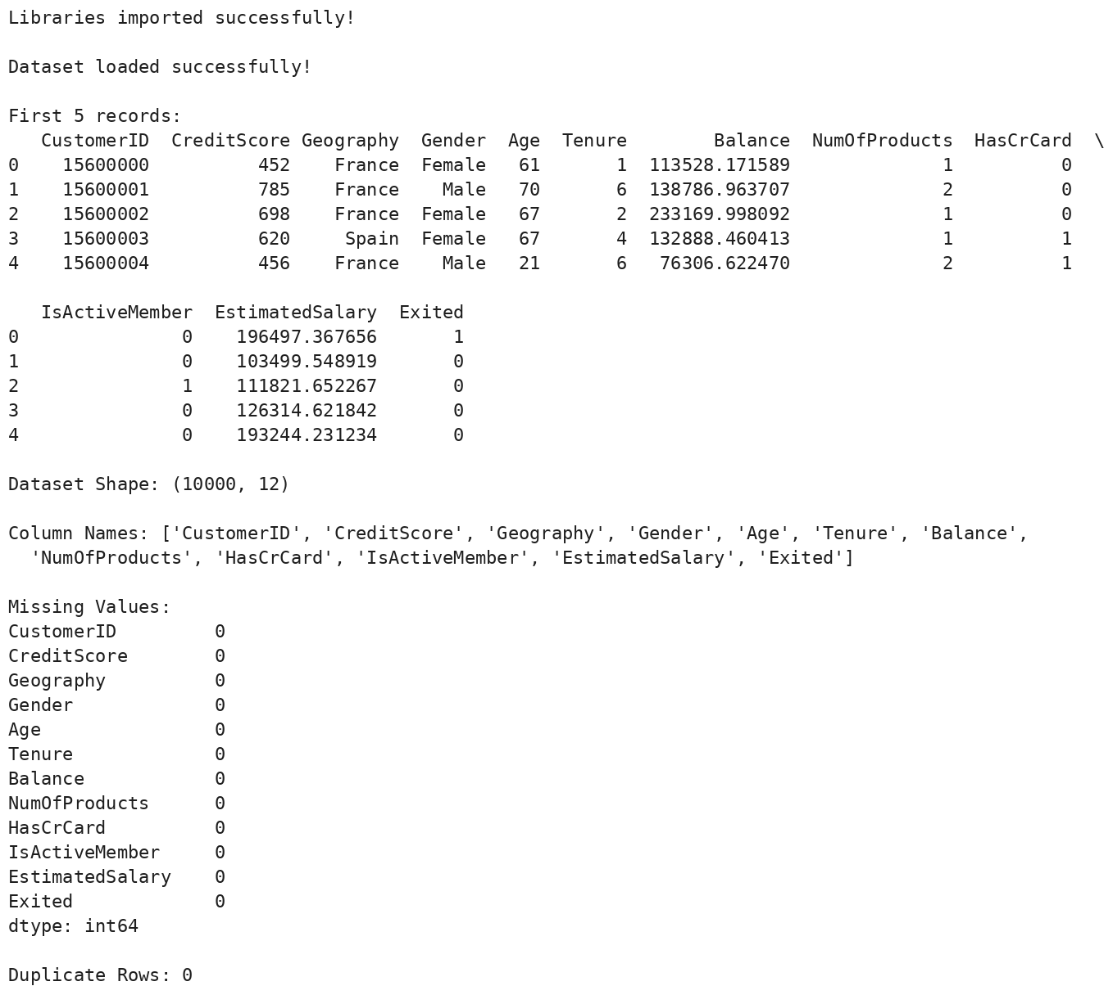
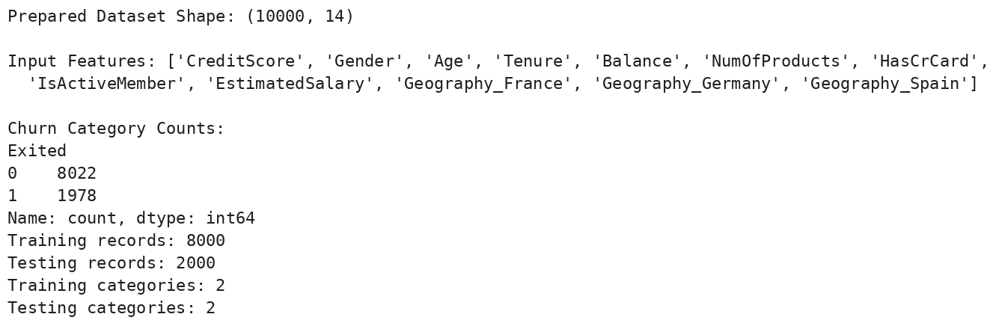
CHAPTER 3 – MODEL DEVELOPMENT
3.1 Logistic Regression
A baseline classifier that estimates the probability of churn from a weighted combination of input features. The pipeline imputes missing values, standardizes features and uses balanced class weights to handle the 80:20 class imbalance.
3.2 Decision Tree
A tree-based classifier that divides records using feature-based rules. The tree is limited to a depth of 3 with balanced class weights; it is interpretable but can only express simple rules.
3.3 Random Forest
An ensemble classifier that combines 100 decision trees (maximum depth 3, balanced class weights). It can model nonlinear patterns and provides feature-importance values.
3.4 Model Training Code and Output
The complete runnable program is provided in the Appendix. The output below confirms the three model names; their evaluation reports follow in Chapter 4.

CHAPTER 4 – MODEL EVALUATION
Metric | Meaning
Accuracy | Fraction of test predictions that are correct
Precision | How many predictions for a class are correct
Recall | How many actual examples of a class are identified
F1-score | Harmonic mean of precision and recall
Confusion Matrix | Counts correct and incorrect predictions by class

Precision, recall and F1-score are reported as macro averages, which give the retained and churned classes equal weight. The test set contains 2,000 customers: 1,604 retained and 396 churned.
4.1 Logistic Regression Evaluation
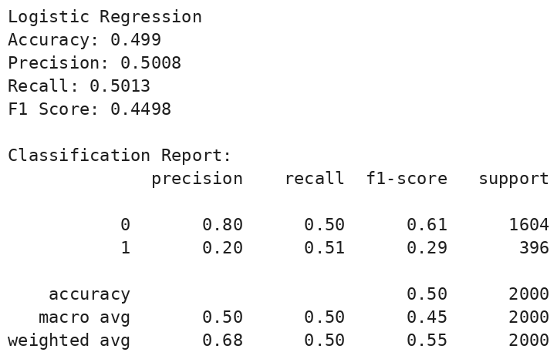
Logistic Regression correctly classified 49.9% of the test customers. It identified 51% of the actual churners (recall 0.51), but only 20% of the customers it flagged as churners were correct (precision 0.20), which is the same as the overall churn rate of about 20%.
4.2 Decision Tree Evaluation
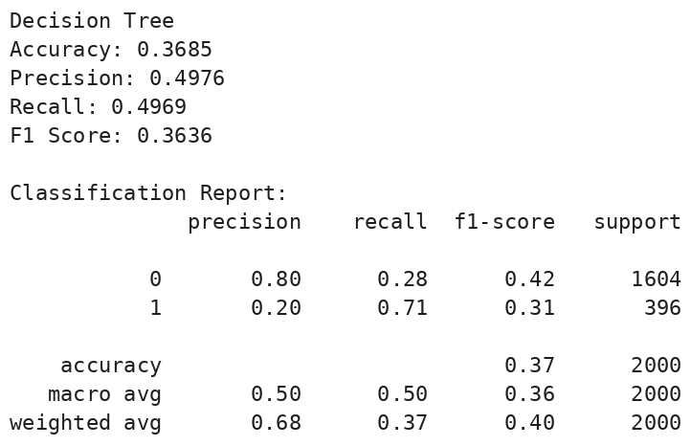
The Decision Tree obtained the lowest accuracy (0.3685). It flagged most customers as churners, so its churn recall is high (0.71) while its churn precision remains 0.20 and its recall for retained customers is only 0.28.
4.3 Random Forest Evaluation
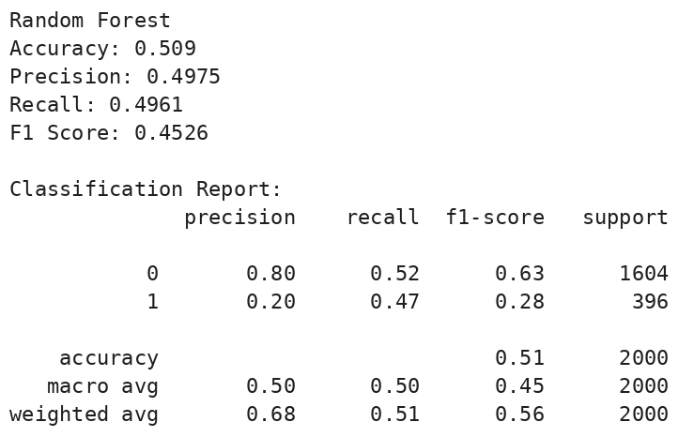
Random Forest reached an accuracy of 0.509 with a churn recall of 0.47 and a churn precision of 0.20, so it performs about the same as Logistic Regression.
Note: These scores are reported exactly as printed by the notebook. Because the churn labels in this dataset are random, small differences between models should not be treated as meaningful.
4.4 Confusion Matrices
Rows show the actual class and columns the predicted class (0 = Retained, 1 = Churned). Logistic Regression: 798 / 806 / 196 / 200; Decision Tree: 456 / 1,148 / 115 / 281; Random Forest: 830 / 774 / 208 / 188 (true retained, false churn, missed churn, true churn).
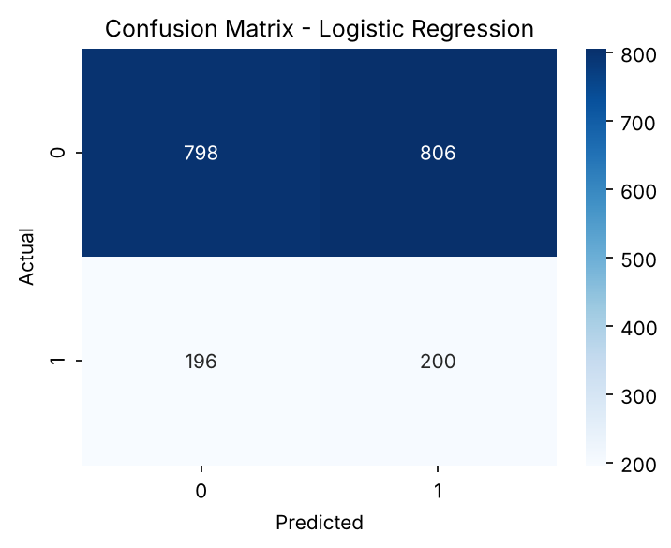
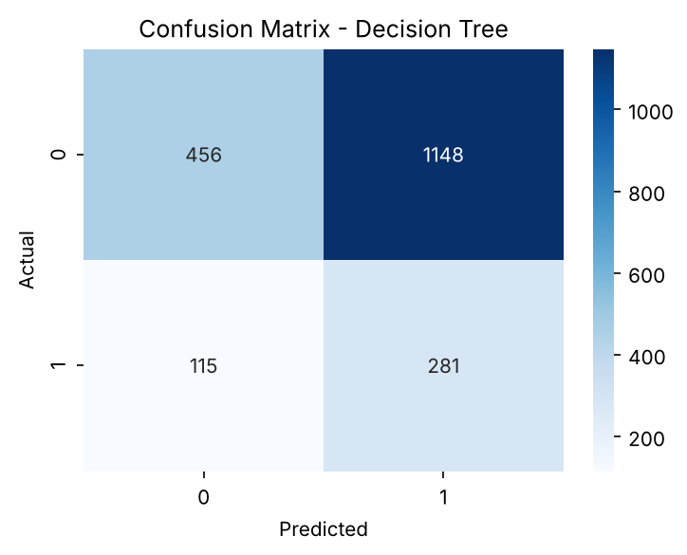
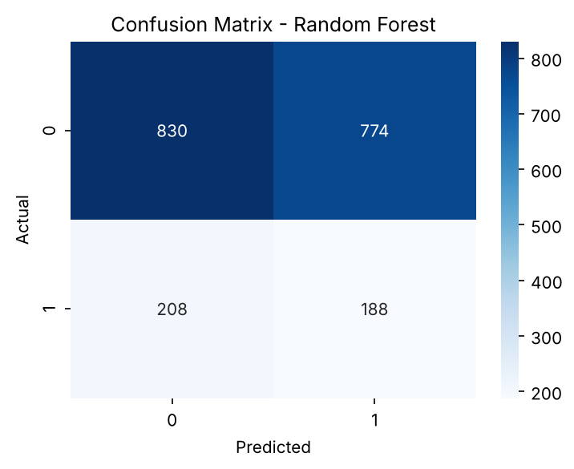
CHAPTER 5 – MODEL COMPARISON
The program sorts the three models by macro F1-score. The printed comparison table identifies the strongest model on this particular test split; precision, recall and confusion matrices are considered as well.
Model | Accuracy | Macro Precision | Macro Recall | Macro F1
Random Forest | 0.5090 | 0.4975 | 0.4961 | 0.4526
Logistic Regression | 0.4990 | 0.5008 | 0.5013 | 0.4498
Decision Tree | 0.3685 | 0.4976 | 0.4969 | 0.3636

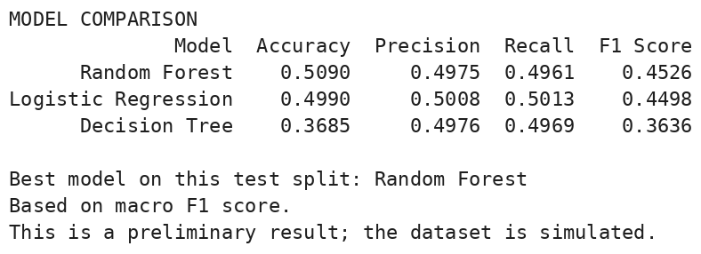
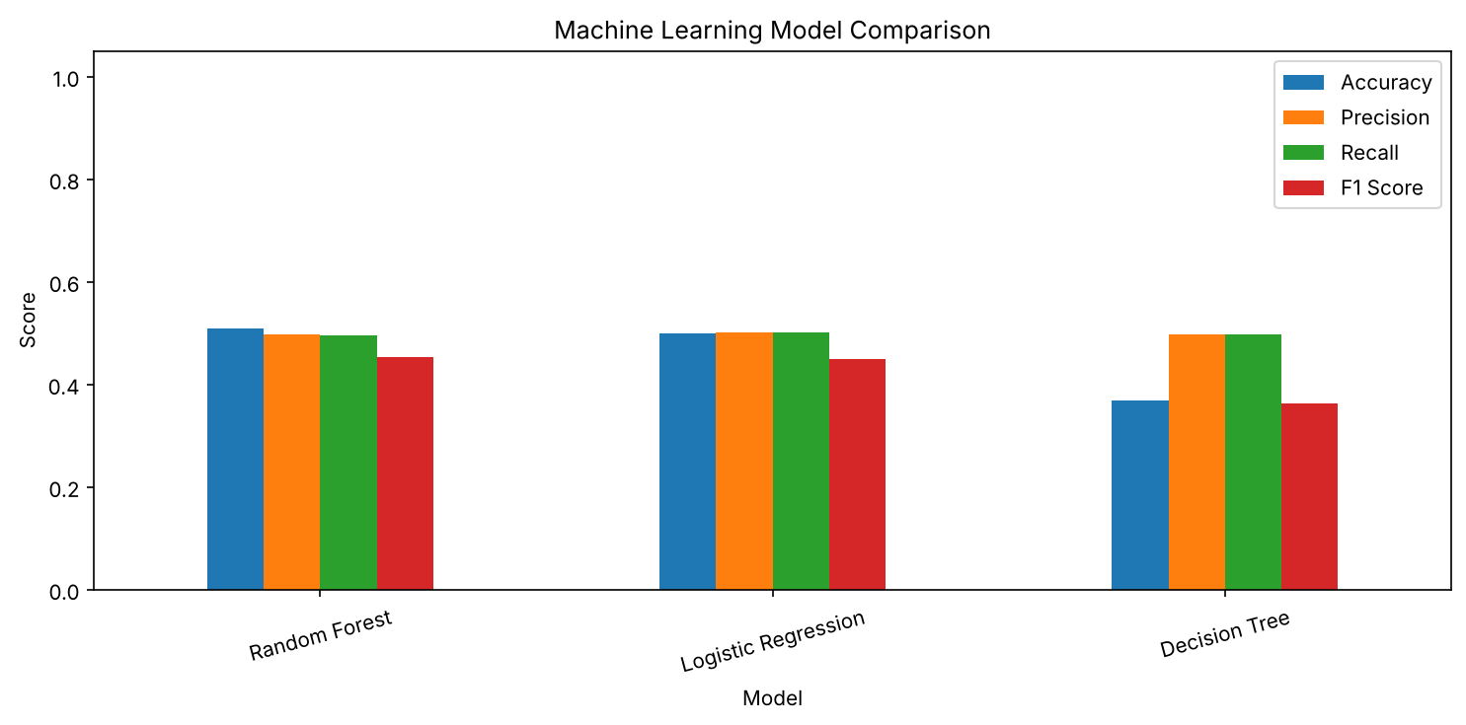
Random Forest has the highest macro F1-score on this run, but its lead over Logistic Regression is only 0.0028, and all three models have macro precision and recall of about 0.50, which is what random guessing between two classes would give. The best model here is therefore not a reliable churn predictor and is not ready for real-world use.
CHAPTER 6 – RESULT ANALYSIS
6.1 Existing Exploratory Findings
- The cleaned dataset contains 10,000 records and 12 variables.
- There are no missing values and no duplicate rows.
- 19.78% of customers (1,978) churned and 80.22% (8,022) were retained.
- Churn is close to one-fifth in every country and for both genders, and the age distributions of retained and churned customers are nearly identical (median about 46 years).
- The earlier correlation matrix reported all coefficients between −0.03 and 0.03, including every correlation with Exited.
- These sample correlations do not establish causation.
The near-zero correlations already suggested that the models would find little to learn, and the results in Chapters 4 and 5 are consistent with this.
6.2 Feature Importance
The code prints feature-importance values and graphs for Decision Tree and Random Forest. Feature importance describes how a trained model uses features; it does not prove causation.
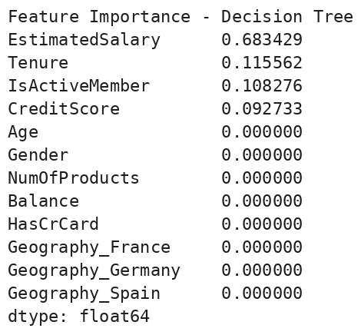
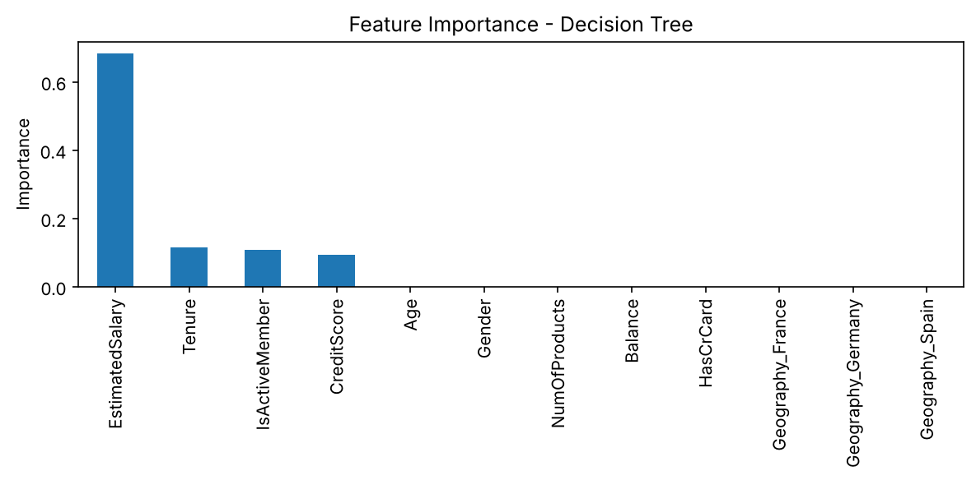
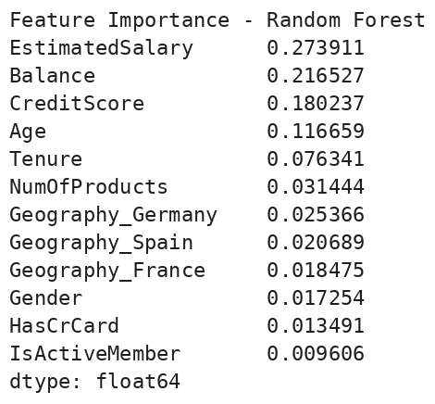
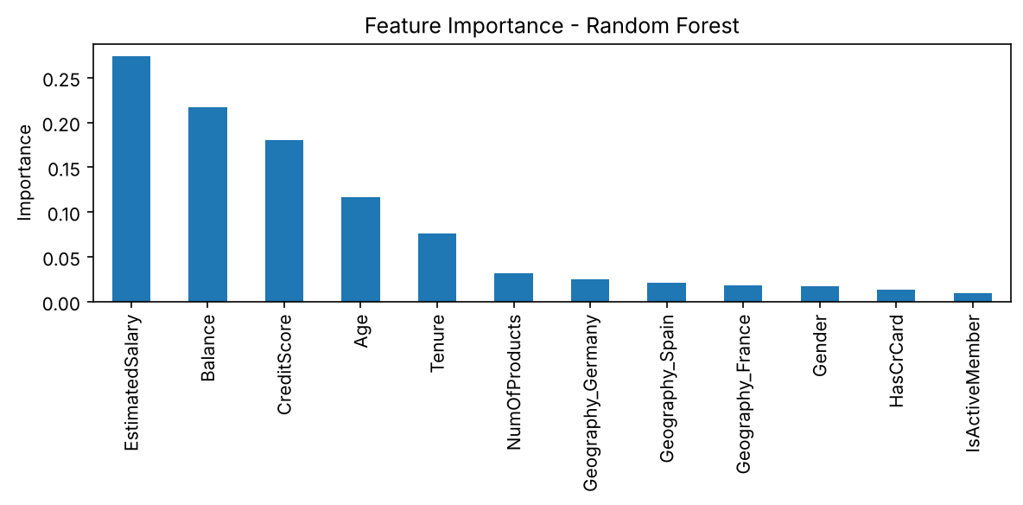
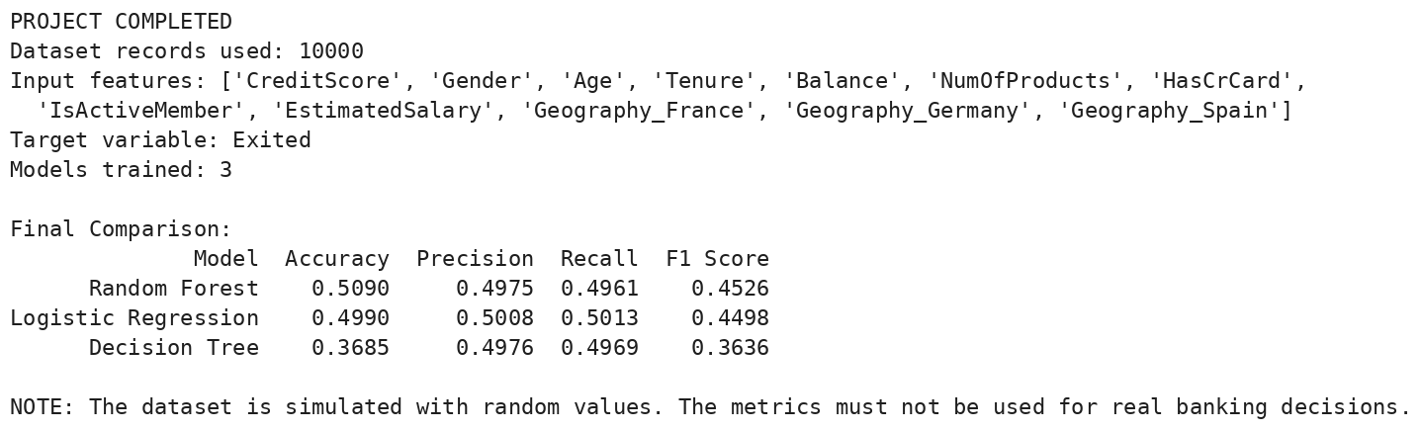
The Decision Tree assigns most importance to EstimatedSalary (0.683), followed by Tenure (0.116), IsActiveMember (0.108) and CreditScore (0.093). Random Forest spreads importance over EstimatedSalary (0.274), Balance (0.217), CreditScore (0.180) and Age (0.117). The two rankings differ, and continuous variables with many distinct values are favoured by tree splits, so given the near-zero correlations these rankings should be treated as noise rather than as genuine churn drivers.
6.3 Limitations
- The dataset was generated by simulation in the notebook with random values, so the churn labels have no real relationship with the features and no model can learn a meaningful pattern.
- All three models score close to chance level (macro precision and recall of about 0.50).
- A single train-test split was used, with no cross-validation or hyperparameter tuning.
- Balanced class weights lower accuracy: predicting every customer as retained would give 80.2% accuracy on this test set, but it would identify no churners.
- The project is educational and must not be used for real banking or customer-retention decisions.
6.4 Future Improvements
- Use real, anonymized bank customer data with behavioural information such as transaction frequency, complaints and service usage.
- Apply cross-validation and hyperparameter tuning, and evaluate with ROC-AUC and precision-recall curves.
- Tune the decision threshold and test resampling methods such as SMOTE for the class imbalance.
- Explain model predictions with feature-importance methods such as SHAP and build a retention dashboard for bank managers.
6.5 Real-World Applications
Validated churn models can help banks identify customers who may leave and prioritise retention offers or outreach. This student project, built on simulated data, is not a validated banking system.
CONCLUSION
This project defines Exited as the target and uses twelve input features prepared from the cleaned SmartBank dataset. It describes data preparation and three classifiers—Logistic Regression, Decision Tree and Random Forest—and includes their evaluation and comparison on a stratified test set of 2,000 customers. Random Forest had the highest macro F1-score (0.4526), but all models performed near chance level, which is consistent with the near-zero correlations found in the mini project and with the simulated nature of the data. The results demonstrate the complete model-building workflow and must not be used for real banking decisions.
REFERENCES
- Supplied mini project report: Bank Customer Churn Analysis – Exploratory Data Analysis, Visualization and Data Preprocessing.
- SmartBank customer dataset (10,000 records, 12 columns) used in the EDA assignment notebook.
- Pandas documentation: https://pandas.pydata.org/docs/
- Matplotlib documentation: https://matplotlib.org/stable/
- Seaborn documentation: https://seaborn.pydata.org/
- Scikit-learn documentation: https://scikit-learn.org/stable/
APPENDIX – COMPLETE CODE
# 1. Import Libraries
import pandas as pd
import numpy as np
import matplotlib.pyplot as plt
import seaborn as sns

from sklearn.model_selection import train_test_split
from sklearn.pipeline import Pipeline
from sklearn.preprocessing import StandardScaler
from sklearn.impute import SimpleImputer
from sklearn.linear_model import LogisticRegression
from sklearn.tree import DecisionTreeClassifier
from sklearn.ensemble import RandomForestClassifier
from sklearn.metrics import (
accuracy_score, precision_score, recall_score,
f1_score, confusion_matrix, classification_report
)
print("Libraries imported successfully!")

# 2. Recreate the cleaned dataset (clean_df) exactly as in the mini project notebook
np.random.seed(42)
n_samples = 10000

data = {
'CustomerID': range(15600000, 15610000),
'CreditScore': np.random.randint(350, 850, size=n_samples),
'Geography': np.random.choice(['France', 'Spain', 'Germany'], size=n_samples, p=[0.5, 0.25, 0.25]),
'Gender': np.random.choice(['Male', 'Female'], size=n_samples, p=[0.52, 0.48]),
'Age': np.random.randint(18, 75, size=n_samples),
'Tenure': np.random.randint(0, 10, size=n_samples),
'Balance': np.random.uniform(0, 250000, size=n_samples),
'NumOfProducts': np.random.choice([1, 2, 3, 4], size=n_samples, p=[0.5, 0.4, 0.08, 0.02]),
'HasCrCard': np.random.choice([0, 1], size=n_samples, p=[0.3, 0.7]),
'IsActiveMember': np.random.choice([0, 1], size=n_samples, p=[0.48, 0.52]),
'EstimatedSalary': np.random.uniform(10000, 200000, size=n_samples),
'Exited': np.random.choice([0, 1], size=n_samples, p=[0.8, 0.2])
}
raw_df = pd.DataFrame(data)
clean_df = raw_df.drop_duplicates().dropna()

# Save the cleaned data as a CSV file and use it as the model input
clean_df.to_csv("cleaned_bank_churn_data.csv", index=False)
df = pd.read_csv("cleaned_bank_churn_data.csv")

# Clean column names
df.columns = df.columns.astype(str).str.strip()
pd.set_option("display.max_columns", None)
pd.set_option("display.width", 110)
print("\nDataset loaded successfully!")
print("\nFirst 5 records:")
print(df.head())
print("\nDataset Shape:", df.shape)
print("\nColumn Names:", df.columns.tolist())
print("\nMissing Values:")
print(df.isnull().sum())
print("\nDuplicate Rows:", df.duplicated().sum())

# 3. Clean Column Names
df.columns = df.columns.astype(str).str.strip()
pd.set_option("display.max_columns", None)
pd.set_option("display.width", 110)
print("\nDataset loaded successfully!")
print("\nFirst 5 records:")
print(df.head())
print("\nDataset Shape:", df.shape)
print("\nColumn Names:", df.columns.tolist())
print("\nMissing Values:")
print(df.isnull().sum())
print("\nDuplicate Rows:", df.duplicated().sum())

# 4. Validate Required Columns
target = "Exited"
features = [
"CreditScore", "Geography", "Gender", "Age", "Tenure",
"Balance", "NumOfProducts", "HasCrCard",
"IsActiveMember", "EstimatedSalary"
]
required = features + [target]
missing_columns = [c for c in required if c not in df.columns]
if missing_columns:
raise ValueError(
f"Missing columns: {missing_columns}. "
f"Available columns: {df.columns.tolist()}"
)

# 5. Data Preparation
df = df.dropna(subset=[target]).copy()

# CustomerID is only an identifier, so it is not used as a feature
# Encode categorical variables (Gender -> 0/1, Geography -> one-hot columns)
df["Gender"] = df["Gender"].map({"Female": 0, "Male": 1})
df = pd.get_dummies(df, columns=["Geography"], dtype=int)

# Convert feature columns to numeric
features = [c for c in df.columns if c not in ["CustomerID", target]]
for col in features:
df[col] = pd.to_numeric(df[col], errors="coerce")

# Remove rows where all feature values are missing
df = df.dropna(subset=features, how="all")
X = df[features]
y = df[target]

print("Prepared Dataset Shape:", df.shape)
print("\nInput Features:", features)
print("\nChurn Category Counts:")
print(y.value_counts())
if y.nunique() < 2:
raise ValueError(
"At least two Exited categories are needed for classification."
)

# 6. Train-Test Split
class_counts = y.value_counts()
number_of_classes = y.nunique()

# Ensure the test set can hold at least one record per class
test_records = max(
int(np.ceil(0.20 * len(y))),
number_of_classes
)

# Ensure enough records remain for training
if test_records >= len(y):
raise ValueError(
"Dataset is too small for a train-test split. "
"Add more records to the dataset."
)
stratify_y = (
y if class_counts.min() >= 2 else None
)
X_train, X_test, y_train, y_test = train_test_split(
X,
y,
test_size=test_records,
random_state=42,
stratify=stratify_y
)
print("Training records:", len(X_train))
print("Testing records:", len(X_test))
print("Training categories:", y_train.nunique())
print("Testing categories:", y_test.nunique())

# 7. Create Three Machine Learning Models
models = {
"Logistic Regression": Pipeline([
("imputer", SimpleImputer(strategy="median")),
("scaler", StandardScaler()),
("model", LogisticRegression(
max_iter=2000, class_weight="balanced"
))
]),
"Decision Tree": Pipeline([
("imputer", SimpleImputer(strategy="median")),
("model", DecisionTreeClassifier(
max_depth=3,
random_state=42,
class_weight="balanced"
))
]),
"Random Forest": Pipeline([
("imputer", SimpleImputer(strategy="median")),
("model", RandomForestClassifier(
n_estimators=100,
max_depth=3,
random_state=42,
class_weight="balanced"
))
])
}
print("Models created:", list(models.keys()))

# 8. Train and Evaluate Models
results = []
trained_models = {}
def evaluate(name, model):
print(name)
model.fit(X_train, y_train)
predictions = model.predict(X_test)
trained_models[name] = model
accuracy = accuracy_score(y_test, predictions)
precision = precision_score(
y_test, predictions,
average="macro", zero_division=0
)
recall = recall_score(
y_test, predictions,
average="macro", zero_division=0
)
f1 = f1_score(
y_test, predictions,
average="macro", zero_division=0
)
results.append({
"Model": name,
"Accuracy": round(accuracy, 4),
"Precision": round(precision, 4),
"Recall": round(recall, 4),
"F1 Score": round(f1, 4)
})
print("Accuracy:", round(accuracy, 4))
print("Precision:", round(precision, 4))
print("Recall:", round(recall, 4))
print("F1 Score:", round(f1, 4))
print("\nClassification Report:")
print(classification_report(
y_test, predictions, zero_division=0
))
# Confusion Matrix
cm = confusion_matrix(
y_test, predictions, labels=np.unique(y)
)
plt.figure(figsize=(5, 4))
sns.heatmap(cm, annot=True, fmt="d", cmap="Blues")
plt.title(f"Confusion Matrix - {name}")
plt.xlabel("Predicted")
plt.ylabel("Actual")
plt.tight_layout()
plt.show()
evaluate("Logistic Regression", models["Logistic Regression"])

evaluate("Decision Tree", models["Decision Tree"])

evaluate("Random Forest", models["Random Forest"])

# 9. Compare All Models
comparison = pd.DataFrame(results)
comparison = comparison.sort_values(
by="F1 Score", ascending=False
)
print("MODEL COMPARISON")
print(comparison.to_string(index=False))

# 10. Display Best Model on This Test Split
best_model_name = comparison.iloc[0]["Model"]
print("\nBest model on this test split:", best_model_name)
print("Based on macro F1 score.")
print("This is a preliminary result; the dataset is simulated.")

# 11. Model Comparison Graph
comparison.plot(
x="Model",
y=["Accuracy", "Precision", "Recall", "F1 Score"],
kind="bar",
figsize=(10, 5)
)
plt.title("Machine Learning Model Comparison")
plt.ylabel("Score")
plt.ylim(0, 1.05)
plt.xticks(rotation=15)
plt.tight_layout()
plt.show()

# 12. Feature Importance (Decision Tree and Random Forest)
for name in ["Decision Tree", "Random Forest"]:
fitted_pipeline = trained_models[name]
classifier = fitted_pipeline.named_steps["model"]
importance = pd.Series(
classifier.feature_importances_,
index=features
).sort_values(ascending=False)

print(f"\nFeature Importance - {name}")
print(importance)

importance.plot(
kind="bar",
figsize=(8, 4),
title=f"Feature Importance - {name}"
)
plt.ylabel("Importance")
plt.tight_layout()
plt.show()

# 13. Final Summary
print("\nPROJECT COMPLETED")
print("Dataset records used:", len(df))
print("Input features:", features)
print("Target variable:", target)
print("Models trained:", len(trained_models))
print("\nFinal Comparison:")
print(comparison.to_string(index=False))
print(
"\nNOTE: The dataset is simulated with random values. "
"The metrics must not be used for real banking decisions."
)

